Procedures for Carrying Out Duties

To ensure the unit remains in a full state of readiness, supervision is required to ensure all aspects of maintenance are done efficiently and accurately.

As the sections’ Maintenance Chief, you are expected to schedule, direct and supervise the care, inspection and maintenance of the unit’s equipment.

Daily Tasks:

- Supervise all maintenance ensuring proper repair and safety procedures are being followed.

- Supervise subordinate billet holders in the execution of their duties.

Weekly Tasks:

- Ensure Weekly Operator PMCS are accomplished.

- Review maintenance reports and ensure all transactions are submitted in a timely manner.

- To pull a Calibrations Report, go to https://gcssmc-tri.usmc.mil

- After pressing “OK” on the warning page that appears, click on the “EBS Login” button located on the left side of the screen.

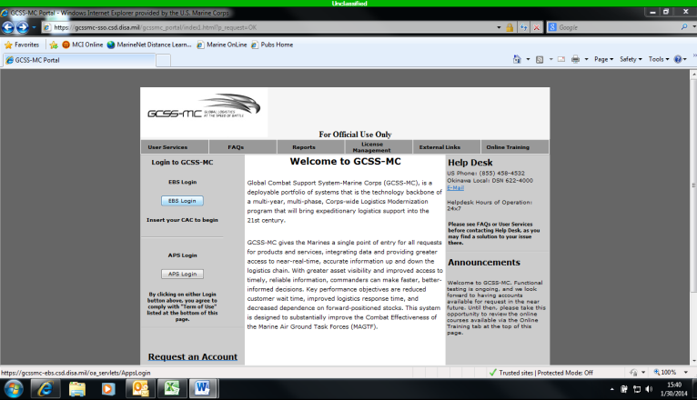

In the new window, under the “Navigator” option list, locate and click on the “Discoverer Reports User” link provided.

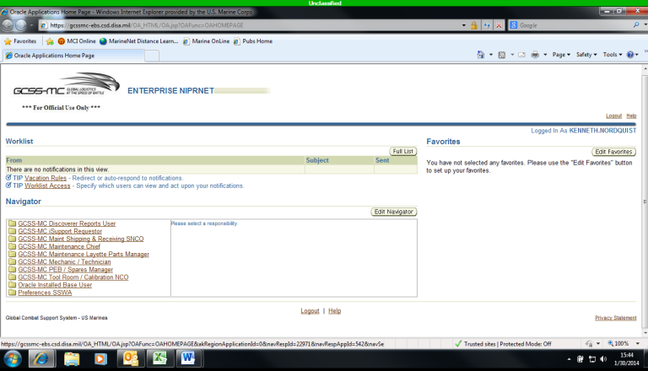

- A new list of links will appear to the right of the original “Navigator” options list. Scroll down the list, and then click the “Calibration Report” link provided.

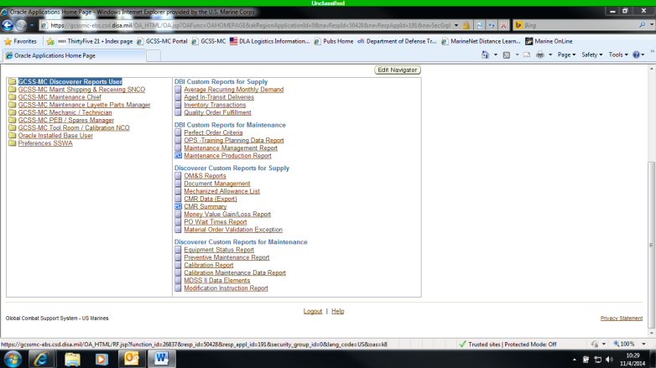

- When the new window appears, click the “Calibration Details” link provided.

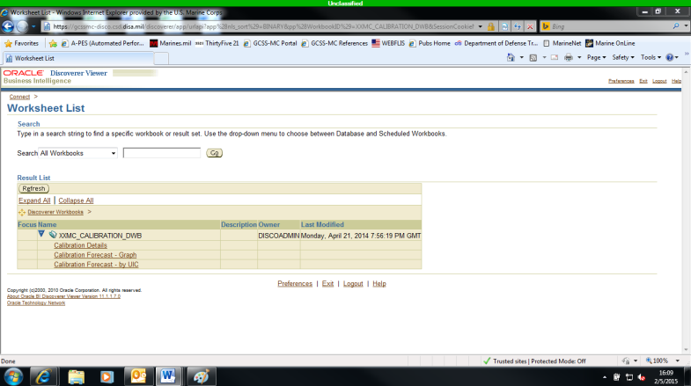

- On the new page, click the “flashlight” link next to the first parameters bar.

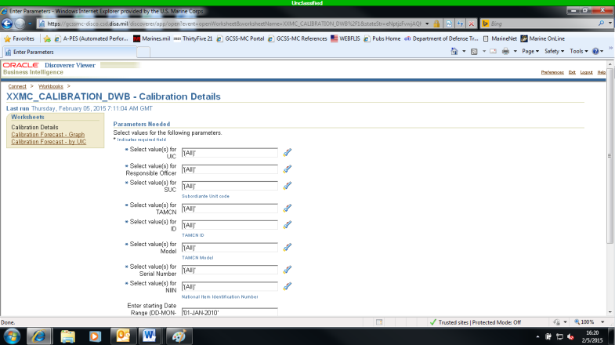

- In the “Search for” bar at the top of the screen, enter your unit RUC (M14201) and click the “Go” button. After the new information is loaded, click in the “Selected” Box on “ALL”, then click the “Remove” button. The next step is to find your unit RUC info in the “Available” box, click on it and then click the “Move” button. Once your unit RUC is visible in the “Selected” box, click the “Select” button on the right hand side of the window. The following picture is a representation of what you should see before clicking the “Select” button. Utilize your section SUC (YM14201_MT) in the search bar provided with the same process to further specify the results.

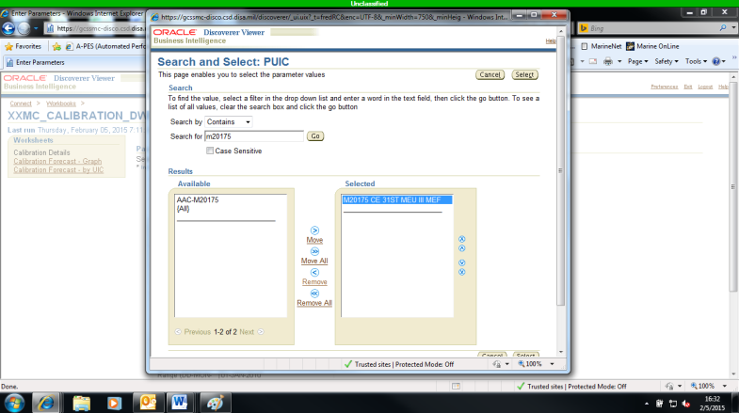

- Your final step is to enter a date range in the bottom two “Parameter” bars. Utilize January 1st as the date information, and go from this past year into the next. There should be a three year gap; this is done to make sure you pull all TMDE asset information.

- Hit the “Go” Button at the bottom left hand corner of the screen and within fifteen minutes, your Calibration Report will appear at the bottom of the screen.

- To pull a Modifications Report, get back to the “Discoverer Reports User” page, scroll down the list, and then click the “Modification Instruction Report” link provided.

- After pressing “OK, Login” on the warning page that appears, click the flashlight icon next to the “Enter Value(s) for Party Owner” search bar on the new page that appears.

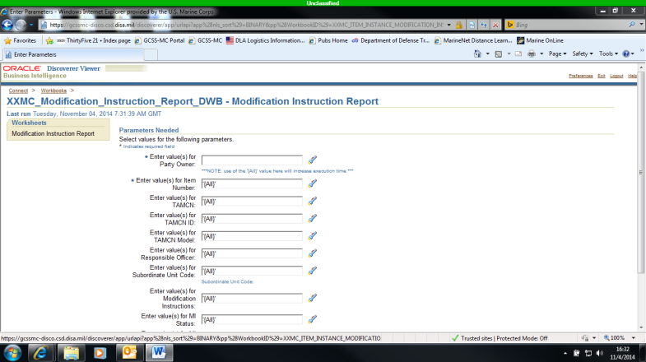

- Type your unit RUC in the “Search for” search bar at the top of the screen and then click the “Go” button.

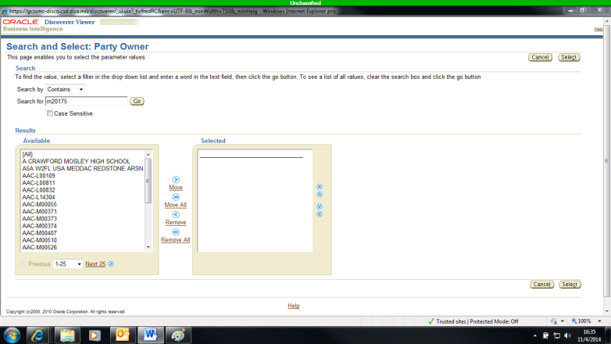

- When your unit appears in the results box, double click it to transfer it to the selected box next to it. After the transfer between boxes occurs, click the “Select” button at the bottom right of the screen to continue. (Note: Remember, using the same process, type in your section SUC to further specify the information in the search bar provided.)

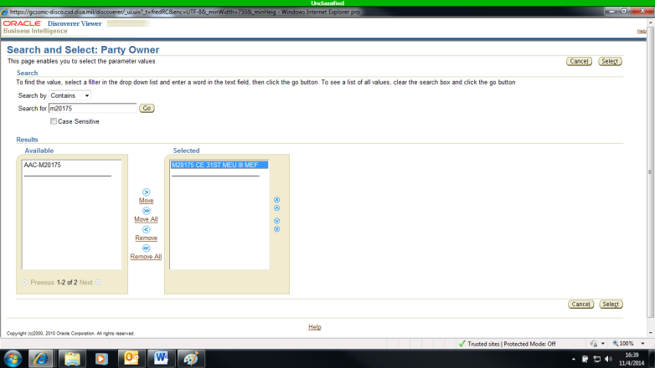
- On the new screen that appears, click the flashlight icon next to the “Enter value(s) for TAMCN:” search bar.

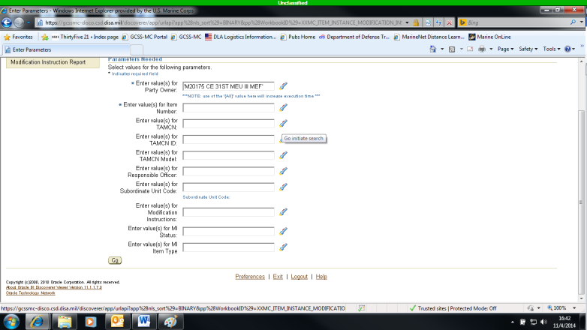

- Using the same process as before, search each individual TAMCN listed on your T/E and/or CMR moving all applicable TAMCN from the “Available” box to the “Selected” box. When all relevant TAMCN have been located, click the “Select” button at the bottom right hand side of the screen.

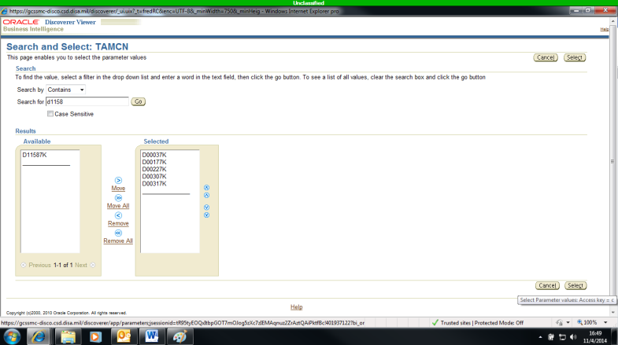

- Once all your search parameters are in place, click the “Go” button on the bottom left hand sign of the screen.

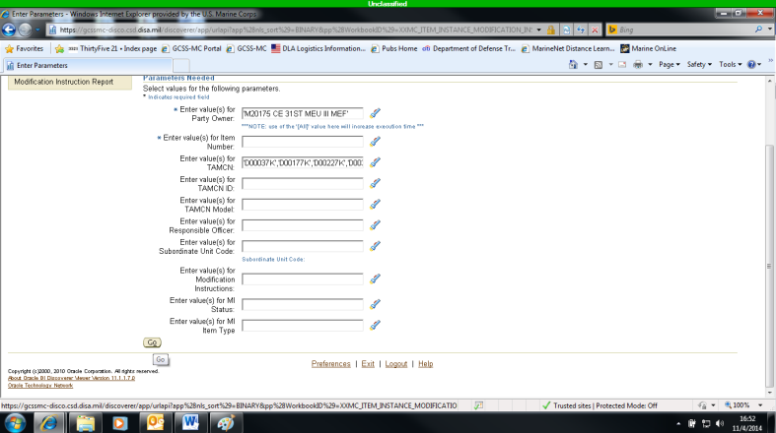
- Once the modification report generates, which can take some time, check the “Actions” list of options on the left hand side of the screen. Click the “Export” link provided.

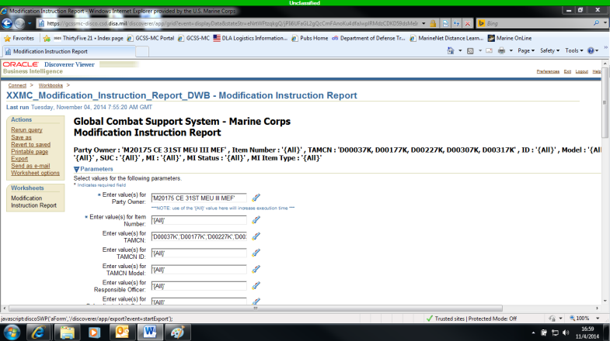

- On the drop down list provided, select “Microsoft Exchange Workbook (*.xls)”. Once selected, click the “Export” button provided on the right hand side of the screen.

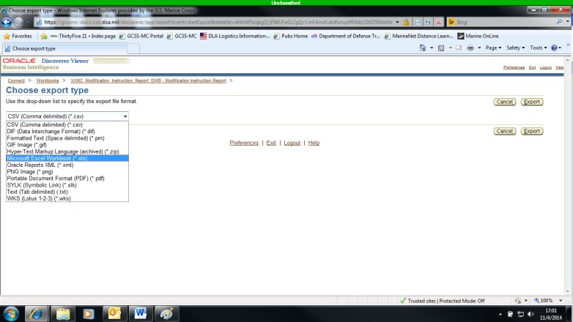

- Utilize the “Click to view or save” button on the new screen and a usable copy of your modification report is now accessible.

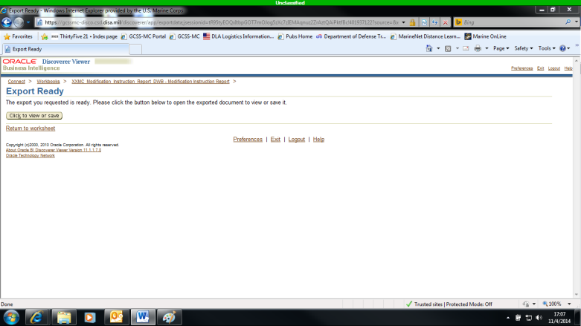

- To pull a Maintenance Production Report (MPR), get back to the “Discoverer Reports User” page, scroll down the list, and then click the “Maintenance Production Report” link provided.

- On the new screen that appears, utilize the field parameters provided to narrow down the MPR to what is relevant to your shop.

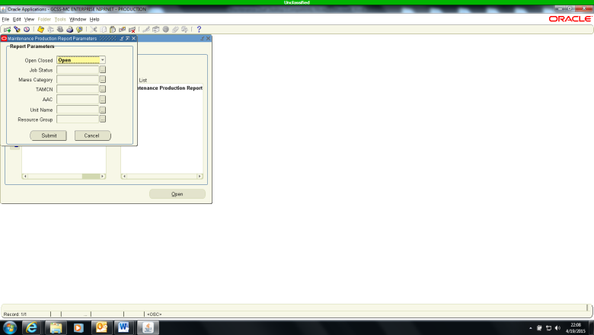

- After entering your Unit Ruc Number, the Group you utilize when making service requests (AAC-M14201_HQ_MT) and any other parameters you feel necessary, click the “find” button. On the New screen that appears, verify the information you previously provided then click the “submit” button to run the report.

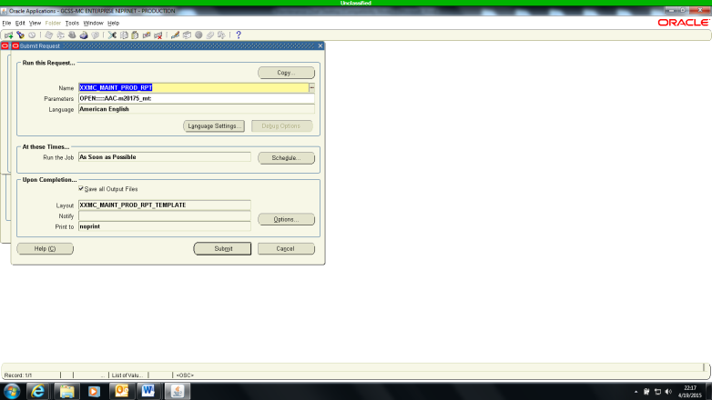
- Once that is accomplished, go to the top of the screen and click the “view” tab, scroll down and click the “requests” option.

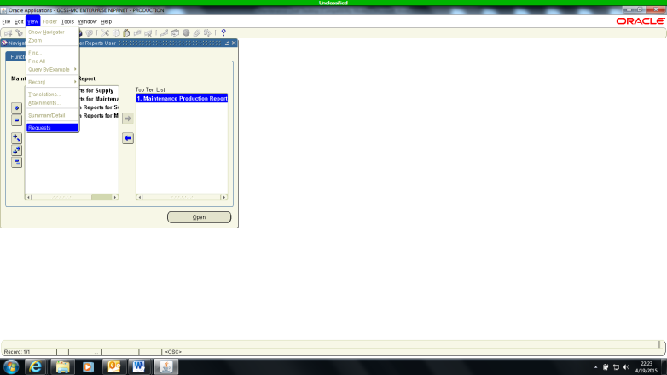

- On the new screen that appears, highlight the “all my requests” field at the top, and then click the “find” button at the bottom.

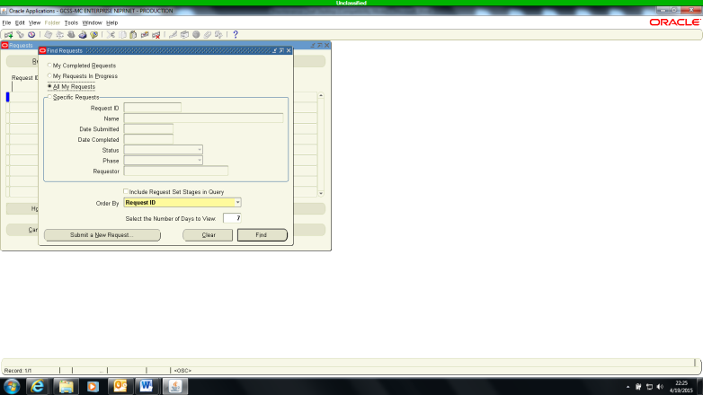

- In this new window, click on the line of text relevant to this most recent report request, cthen click on the “view output” button and your report is ready for you.

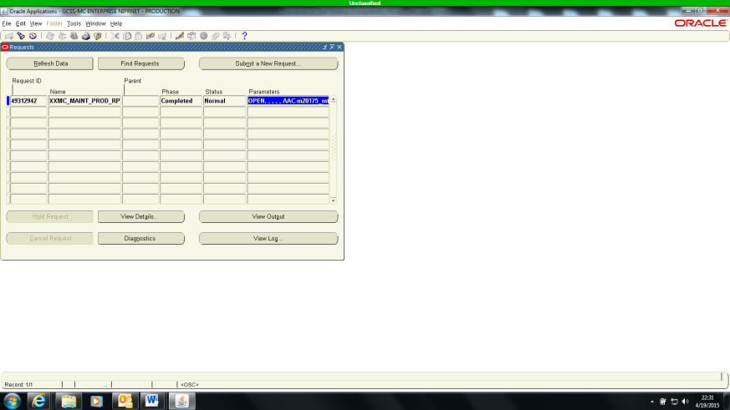

Bi-Weekly Tasks:

- Meet with a supply representative and the Maintenance Management Chief to participate in reconciliation.

- To ensure you maintain a high state of readiness, on hand equipment has at least an annual PMCS requirement. Pull a PMCS report to verify the PMCS schedule is being adhered to.

- To pull a PMCS Report, go to https://gcssmc-tri.usmc.mil

- After pressing “OK” on the warning page that appears, click on the “EBS Login” button located on the left side of the screen.

In the new window, under the “Navigator” option list, locate and click on the “Discoverer Reports User” link provided.

- A new list of links will appear to the right of the original “Navigator” options list. Scroll down the list, and then click the “Preventative Maintenance Report” link provided.

- On the new window, click the “Preventative Maintenance” link provided on the left hand side of the screen.

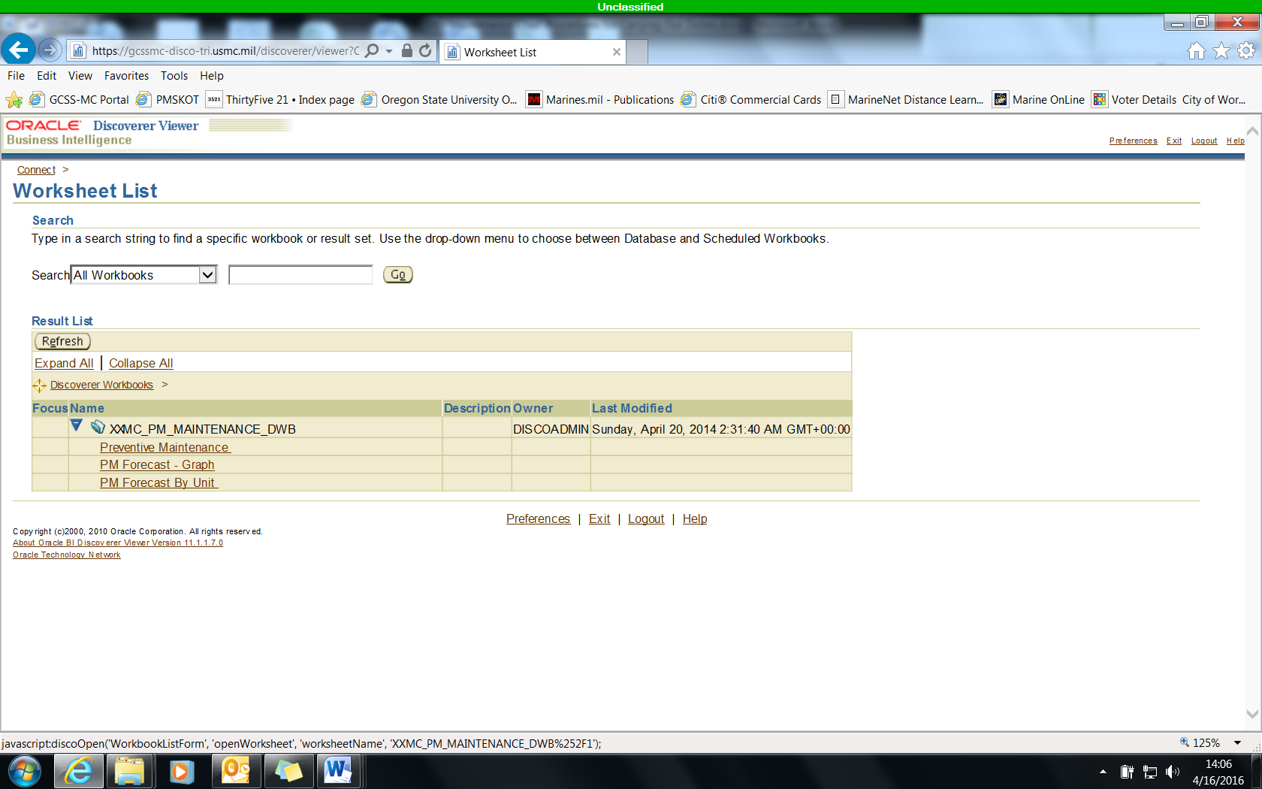
- After pressing “OK, Login” on the warning page that appears, click the flashlight icon next to the “Enter Value(s) for Party Owner” search bar on the new page that appears.

- Type your unit RUC in the “Search for” search bar at the top of the screen and then click the “Go” button.

- When your unit appears in the results box, double click it to transfer it to the selected box next to it. After the transfer between boxes occurs, click the “Select” button at the bottom right of the screen to continue. (Note: Remember, using the same process, type in your section SUC to further specify the information in the search bar provided.)

- On the new screen that appears, click the flashlight icon next to the “Enter value(s) for TAMCN:” search bar.

- Using the same process as before, search each individual TAMCN listed on your T/E and/or CMR moving all applicable TAMCN from the “Available” box to the “Selected” box. When all relevant TAMCN have been located, click the “Select” button at the bottom right hand side of the screen.

- Once all your search parameters are in place, click the “Go” button on the bottom left hand sign of the screen.

- Once the modification report generates, which can take some time, check the “Actions” list of options on the left hand side of the screen. Click the “Export” link provided.

- On the drop down list provided, select “Microsoft Exchange Workbook (*.xls)”. Once selected, click the “Export” button provided on the right hand side of the screen.

- Utilize the “Click to view or save” button on the new screen and a usable copy of your modification report is now accessible.

Monthly Tasks:

- Ensure Publications NCO updates Publication Management System (PLMS) information.

- Verify OVE NCO has supervised and/or assisted with the monthly COEI, BII and AAL inventories.

- Ensure Monthly Operator PMCS are accomplished.

Quarterly:

- Ensure quarterly Tool Room inventories are conducted.

Semi-Annual Tasks:

- In accordance with ForO 4790.3B, this desktop will be reviewed by a commodity manager at a minimum, semi-annually to ensure accuracy and applicability.

Annual Tasks:

- Ensure wall-to-wall inventories of all TMDE and publications are conducted.

- Verify UURI, Garrison Peculiar Tool and AAL authorizations are current.

As Required or Directed:

- Inform Regimental Motor Transport Chief, Motor Transport Officer and S-4 Officer (if appropriate) of any maintenance or operation related issues.

Note: As the Motor Transport Maintenance Chief your responsibilities include, but are not limited to the tasks listed above.

