Miscellaneous Information

TAB TOPIC
. . . . Additional Useful Information
- Stock Lists: Stock Lists provide up to date supply information which is necessary for the maintenance effort.

- Supply Catalogue (SC): A given Army Publication which corresponds to Marine Corps SL-3 and SL-4 listings.

- Stock List 1-1 (SL 1-1): An introduction to the Marine Corps stock list publications and the federal supply catalogue.

- Stock List 1-2 (SL 1-2): An index of authorized publications for equipment support; it is used to determine what publications are needed to support a piece of equipment.

- Stock List 1-3 (SL 1-3): An index of authorized publications in stock; included in it are the publications from other branches of the armed services and commercial contractors which the Marine Corps has adopted and authorized for use.

- Stock List 3 (SL-3): A component list, the SL-3 is used as an inventory guide to an item of equipment.

- Stock List 4 (SL-4): A repairable parts list that links the mechanic/technician to the supply system; it lists and completely identifies those items and materials required to maintain the end item, components and/or major assemblies.

- Stock List 6 (SL-6): An application list, it is used to cross reference an NSN to an Item designator (ID) number.

- Stock List 8 (SL-8): A list of items that are functionally the same and are grouped together for convenience of management at all levels, i.e. blank forms or rifle team equipment.

- Modification Instruction (MI): These instructions are used to support a Marine Corps wide modification program. They are used to correct discrepancies in equipment design; to give equipment increased technical and tactical advantages. There are two types:

  - Normal Modification: The modification must be completed on all affected pieces of equipment within one year of the date of issuance.

  - Urgent Modification: The Modification is issued to prevent personal injury or serious damage to equipment. Message instructions will normally be issued to deadline equipment till the modification is installed. This modification must be completed within the timeframe stated on the MI.

  - Optional Modification: The modification, as its name would suggest, is entirely optional and up to each individual command to have installed. If not installed, you must still maintain a copy of it for your information, but it does not need to be annotated in Install Base, GCSS-MC if not already added.

- MI Useable Action Codes:

  - MI-Not Installed: This is the default status when a MI is first introduced into GCSS-MC Install Base. Use this status until maintenance or administrative action has been initiated and the section is ready to change the status.

  - MI-N/A: Use this status to identify an MI that does not apply to specific serial numbers or because it is not required based on your unit’s specific mission.

  - MI-Verified: Use this status when the prior application of a MI has been visually confirmed.

  - MI-Service Request Open: This status indicates a service request is opened and being used to record work being performed. This status should be utilized when resources such as labor or parts are required to apply the modification.

  - MI-Complete: This status indicates a required modification has been installed while in your unit’s custody.

- To manually enter information into the items instance section of the install base (which acts as the record jacket for tactical equipment) or to attach supporting maintenance documents such as LTI’s, utilize the following steps:

- Go to https://gcssmc-sso.csd.disa.mil/index.html.html

- After pressing “OK” on the warning page that appears, click on the “EBS Login” button located on the left side of the screen.

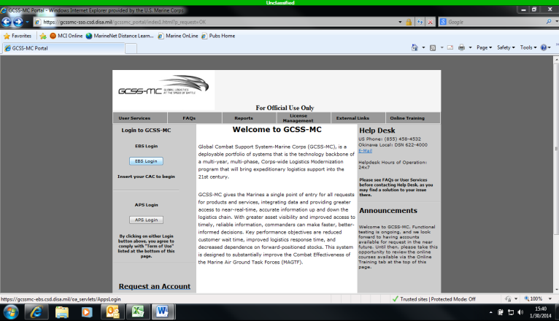

In the new window, under the “Navigator” option list, locate and click on the “Oracle Installed Base User” link provided.

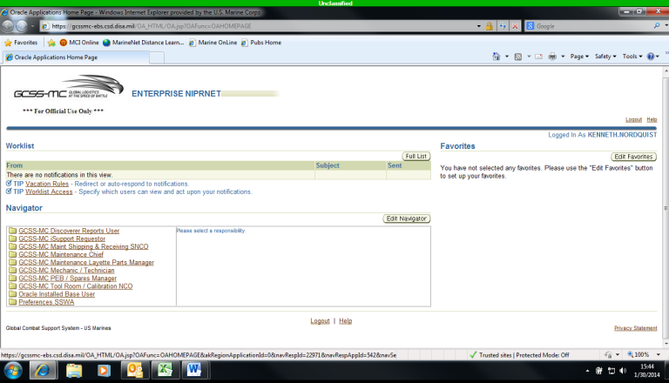

A new list of links will appear to the right of the original “Navigator” options list. Click the “Oracle Installed Base” link provided.

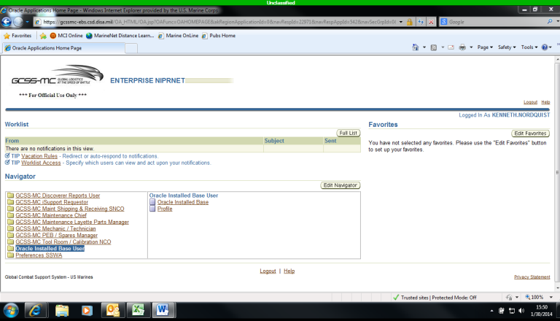

The new window has a “Quick Find” option available for you to search for any gear belonging to your unit. In the scroll down menu next to where it says “Quick Find”, select “Serial Number”.

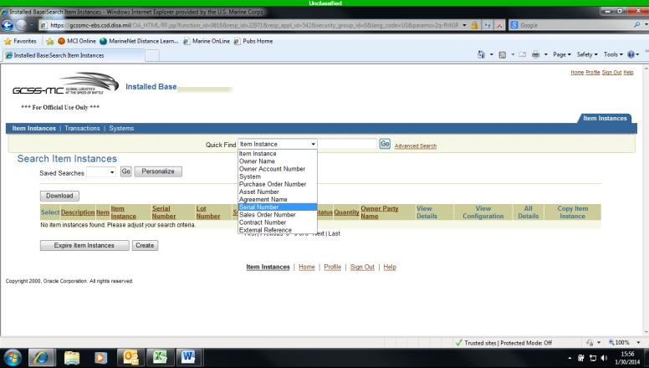

After making your selection, type in the equipment serial number for the piece of gear you wish to look up and then press the “Go” button.

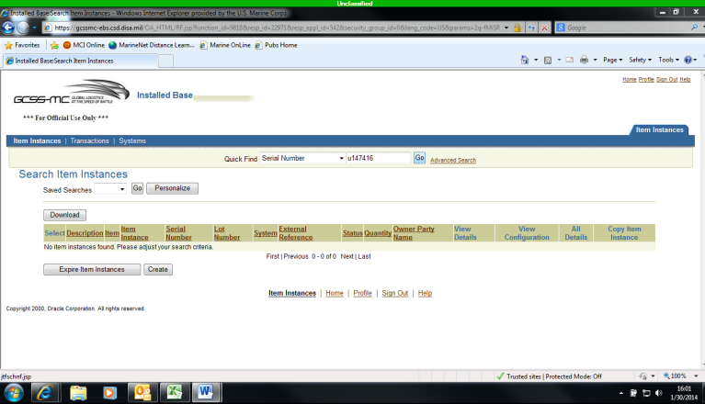

In this new window, click the “Item Description” link.

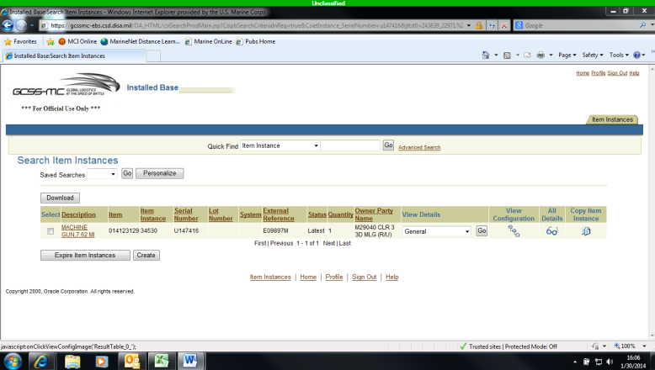
- In the new window, click the “Notes” link on the left hand side of the screen.

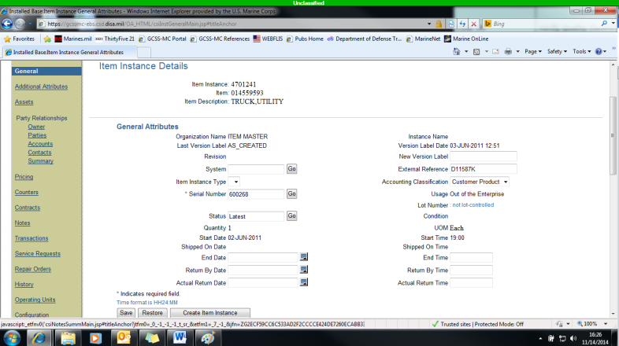

- On the new screen, click on the “Create” button provided.

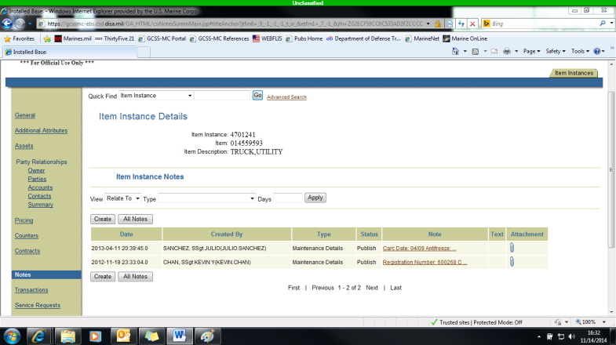

- Once the new screen appears, use the scroll menu for “Type”, select “Maintenance Details” then fill out the “Note” section with relevant information i.e. equipment inducted into maintenance for this defect or load test date. Once entered, utilize the “Create” button again to save the information to install base.

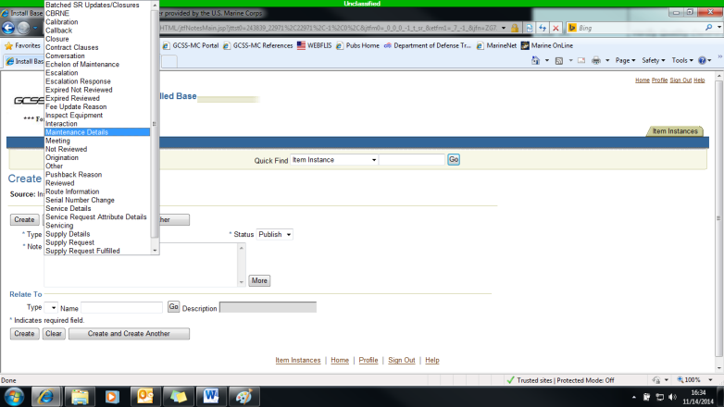

- You will automatically be redirected to the previous screen after saving the new note. You can attach any supporting documentation by using the paperclip icon next to the newly created note. A browse function will automatically appear which can be utilized to search for the document on the computer being utilized.

- Condition Codes:

- A: Serviceable – issuable without qualification. New, used, repaired, or reconditioned material which is serviceable and issuable to all customers without limitation or restriction.

- B: Serviceable – issuable with qualification. New, used, repaired, or reconditioned material which is serviceable and issuable for its intended purpose but is restricted from issue to specific units, activities, or geographical areas by reason of its limited usefulness or short service life expectancy.

- Condition Codes (Continued):

- C: Serviceable – priority issue. Items which are serviceable and issuable to selected customers but which must be issued before Condition Code A or B material to avoid loss as a usable asset.

- D: Serviceable – test/modification. Serviceable material which requires test, alteration, modification, conversion or disassembly. This does not include items which must be inspected or tested immediately prior to issue.

- E: Unserviceable – limited restoration. Material involves only limited expense or effort to restore to serviceable condition, which is accomplished in the storage where the stock is located. Repair cost is 0-10% of the standard unit price.

- F: Unserviceable – repairable. Economically reparable material which requires repair, overhaul, or reconditioning and includes repairable items which are radioactively contaminated.

- G: Unserviceable – incomplete. Material requiring additional parts or components to complete the end item prior to issue.

- H: Unserviceable – condemned. Material which has been determined to be unserviceable and uneconomical to repair. This includes items condemned items which are radioactively contaminated.

- Apply For Access to Marine Publications:

  - To have a functional shop, you must have access to the Marine Corps Technical Publication Site. If you require access, go to the following website and follow the listed steps provided at the bottom of the screen https://mceits.usmc.mil/sites/pubs/default.aspx

- Submit a change to a publication

- The purpose of the NAVMC 10772 is to recommend changes to technical publications. (Note: Typographical errors i.e. spelling and grammar mistakes as well as Federal Supply Classification (FSC) changes need not be reported.) It is the responsibility of the INDIVIDUAL who noticed the error in a given publication, to prepare and submit the NAVMC 10772 form.

- To submit a NAVMC 10772 Form, Go to https://mceits.usmc.mil/sites/pubs/default.aspx

- This main page will have the quick link to the NAVMC 10772; click the link to access the correct form.

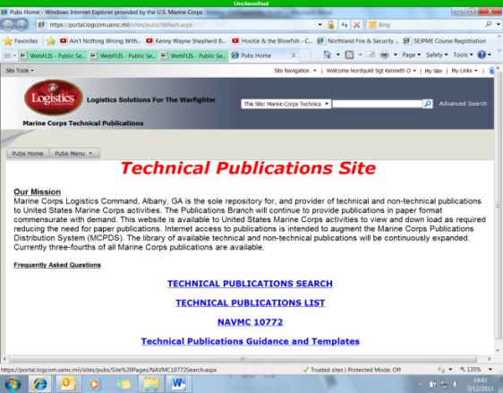
- Follow directions at the top of the page to either add to or start a new NAVMC 10772.

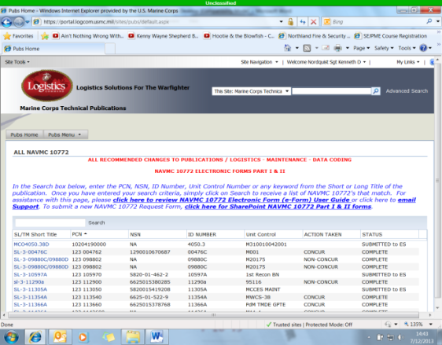
- Classification of Publications:

  - Directives:

    - Non-Technical Publications: Orders and bulletins issued by various echelons of command which provide information and guidance on various maintenance programs. (Note: The requirement to maintain non-technical publications is a judgment call by the commodity manager.)

    - Advanced Logistics Orders (ALO): A document providing information relative to the introduction of new equipment and necessary logistical/supply action required prior to placing the new equipment into service.

  - Technical Publications:

    - Technical Manuals (TM): A technical publication that contains the description of a piece of equipment, along with instructions for effective operation, preventative maintenance, corrective maintenance, and overhaul for said piece of equipment.

- Classification of Publications (Continued):

  - Technical Publications:

    - Joint Service Publication: Similar to a Technical Manual, this publication originates when two or more services coordinate in its authorship for a piece of equipment.

    - Lubrication Instruction/Order (LI/LO): This set of instructions prescribes the types of lubricants to be used, the points to be lubricated and the interval between lubrications for a piece of equipment.

    - Supply Instructions (SI): A set of instructions that furnish supply information that explains the technical aspects of supply for specified items of equipment.

    - Technical Instructions (TI): A set of instructions that gives you added information usually included as a change or revision to a TM. They may also contain information previously included in a TM that can be better disseminated via a smaller instruction i.e. Forms and records to be used, safety and serviceability standards. They can be used to transmit urgent instructions critical to the operation or maintenance of equipment as well.

- Terms and Abbreviations:

- DCP – Directive Control Point, which is responsible for maintaining the units Publication Library (PL).

- EDO – Electronic Distribution Only, these pubs are only available electronically

- FMF – Fleet Marine Force

- FSMAO – Field Supply and Maintenance Analysis Office

- SL – Section Library

- IAAC – Individual Activity Address Code, identifies a unit within the Marine Corps

- IAC – Individual Activity Code, is used interchangeably with IAAC

- ISC – Information Systems Coordinator

- ISMO – Information Systems Management Office

- Local Publications – Physical copies of documentation that users want to keep track of. They consist of such things as: BN orders, Div Orders, etc.

- Master List of Publications – Listing of all USMC publications

- NEA – Non Equipment Associated, this allows you to retain a PCN in your section Library even if the ID number is deleted or obsolete.

- Terms and Abbreviations (Continued):

- PCN – Publication Control Number

- PLMS – Publication Library management System

- SSIC – Standard Subject Identification Codes

- MCPDS – Marine Corps Publication Distribution

- Types of Calibration:

- There are four types of calibration. Calibrated items are instruments with all ranges and functions that have applicable tolerances.

- FULL CALIBRATION – Items that to be accurate across the full range of measurements.

- SPECIAL CALIBRATION – Items that to be accurate across only a portion of measurements.

- CAL NOT REQUIRED – Items that are used for other than quality or quantity measurements and therefore the accuracy of the measurement is not a factor.

- INACTIVE – Items which will not be used to make measurements of a non-critical nature or for instructional purposes only. Some instructional equipment will require full/special calibration. These items will not be calibrated within specific timeframes.

- Four steps in the Calibration Control Program:

- IDENTIFY: Using T/E and Allowance List, identify all TMDE. Using these two reports and FedLog, check for Operational Test Code 3, an indicator of required calibration. TI-4733-15/1 also provides guidance on required calibration items.

- LOCATE: Check with Supply to see who owns specific calibration items. Once determined where items are, establish a calibrations Control Record per TM-4700-15/1. Many calibration items are components of end items.

- INVENTORY: Once items are located, MMO and Maintenance Rep will match the item, calibrations record, T/E, and Allowance to ensure all is accounted for and complete.

- SCHEDULE: End result is establishing Calibration Due Dates. It is the section responsibility that adequate items are on hand to accomplish its mission.

