Miscellaneous Information

TAB TOPIC
. . . . Additional Useful Information
7 . . . Example Log In/Out Sheet

Apply For Access to Marine Publications:

- To be a functional Publications NCO, you must have access to the Marine Corps Technical Publication Site. If you require access, go to the following website and follow the listed steps provided at the bottom of the screen https://mceits.usmc.mil/sites/pubs/default.aspx

Submit a Change to a Publication:

- The purpose of the NAVMC 10772 is to recommend changes to technical publications. (Note: Typographical errors i.e. spelling and grammar mistakes as well as Federal Supply Classification (FSC) changes need not be reported.) It is the responsibility of the INDIVIDUAL who noticed the error in a given publication, to prepare and submit the NAVMC 10772 form.

- To submit a NAVMC 10772 Form, Go to https://mceits.usmc.mil/sites/pubs/default.aspx

- This main page will have the quick link to the NAVMC 10772; click the link to access the correct form.

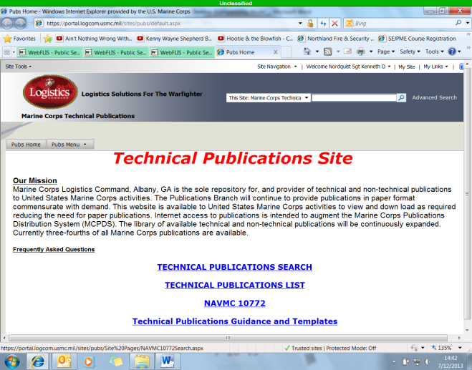
- Follow directions at the top of the page to either add to or start a new NAVMC 10772.

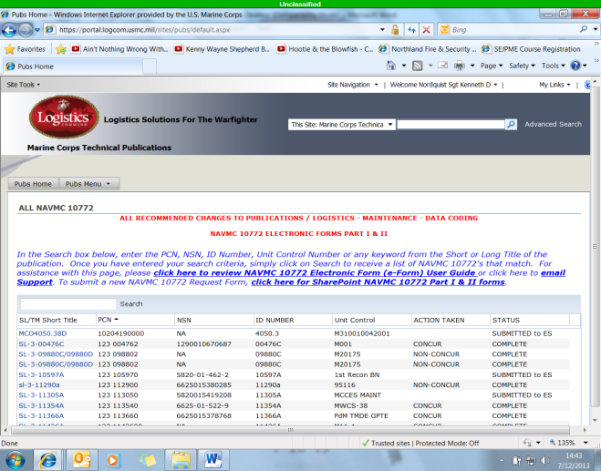
Install PLMS:
- PLMS is the latest program to be developed in the effort to make publication management an easier task. It allows for section library information to be maintained electronically, and with its monthly updates, allows a Marine to stay informed regarding any Marine Corps wide changes to publications. To locate and install PLMS on a computer, use the following steps:

- Go to http://www.marines.mil

- Put the cursor over the “News” tab towards the top left corner of the screen.

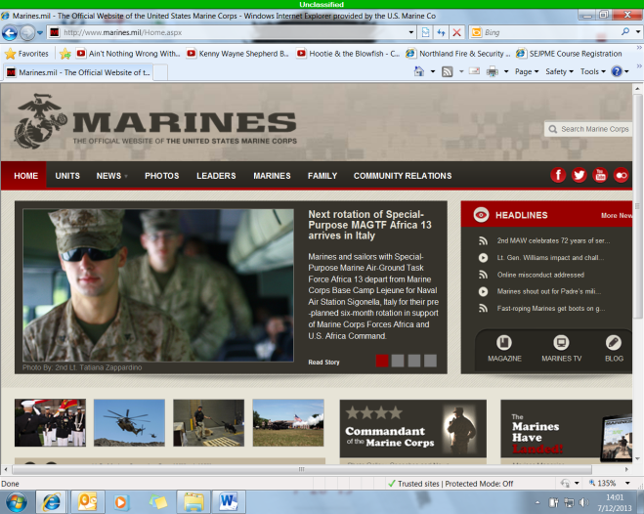
- Scroll down to the “Publications” link in the scroll down list that appears and click it.

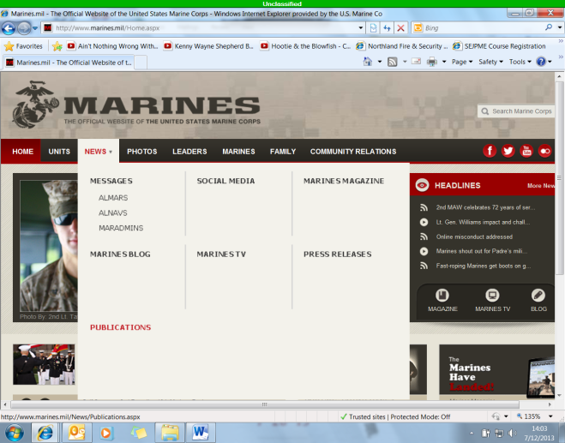

- Scroll down the list that appears at the top of the new screen to “Pubs Library Management System” and click on it.

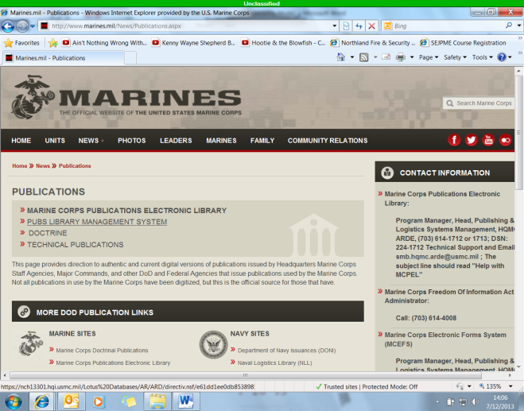
- Click on “continue to this website” on the screen that pops up.

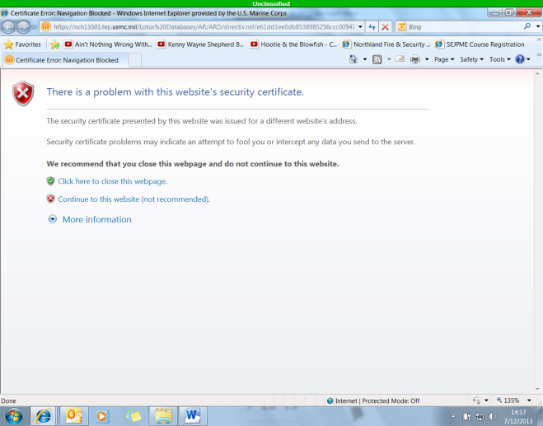
- Scroll down the new screen till you see PLMS 3.0 Setup Files.

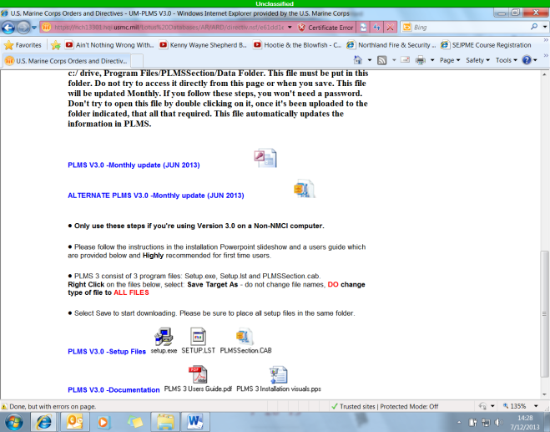

- PLMS consists of 3 program files: Setup.exe, Setup.lst and PLMSSection.CAB. Right Click on these files, select Save Target As, save in c:/ drive, Program Files/PLMSSection/Temp. Make sure to place all three setup files in the same folder. (Note: Do not change the file names, however, be sure to change “Save Type” from “application” or other file type to “all files” when going through the saving process.)

- Once you have saved the three before mentioned files to your computer, double click on Setup.exe

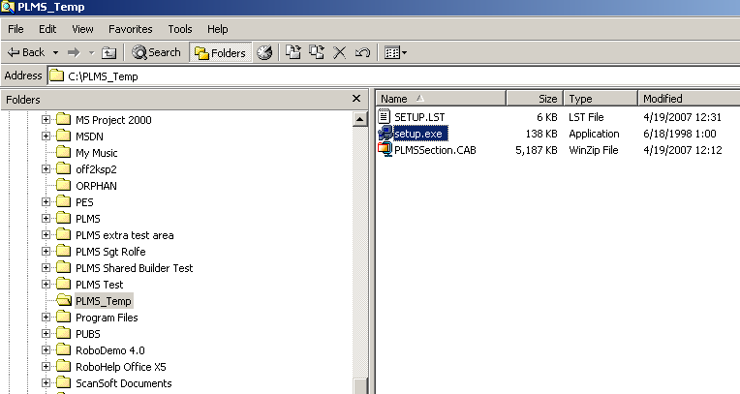
- Close any other active programs, then hit “OK” on the window that pops up.

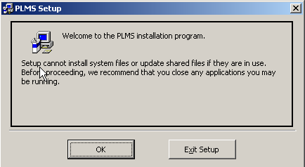

- Click on the icon that looks like a computer in the new window to install in the default location.

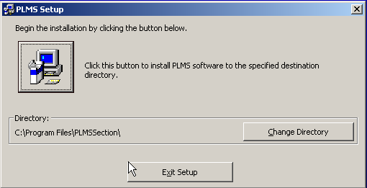
Note: After the installation process has been completed, delete the three setup files you originally downloaded

Instructions to Access Electronic Publications:

- Starting from your computers desktop, access the start menu and scroll with your mouse down to “My Computer” and click. (Note: To view and utilize the electronic copies of the required publications for this shop, you must have access to the computer with the Asset Tag Number 8900094297.)

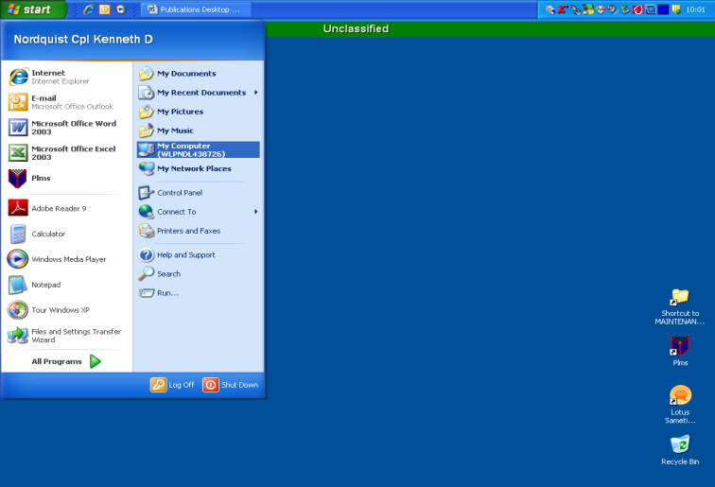

- Double click on the icon at the top left hand corner of the new window that appears. The icon name should include “System (C:)”.

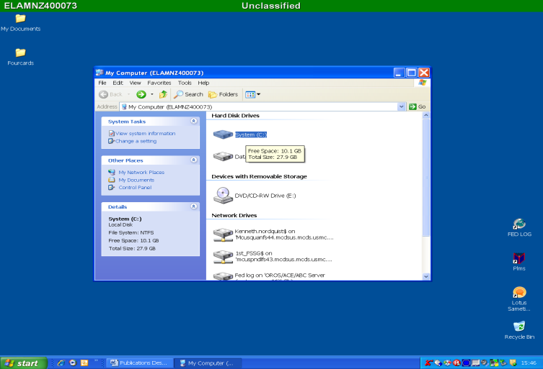
- Scroll down the new window till you find the folder named “Electronic Publications” and double click it.

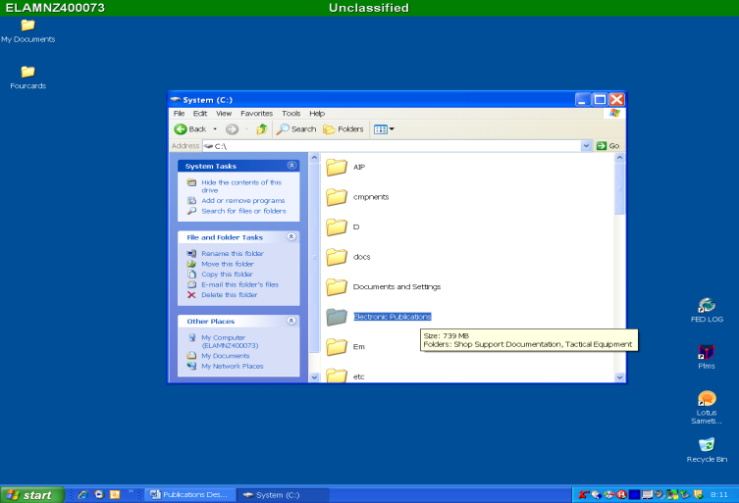
- Double click on the “Technical Publications” folder.

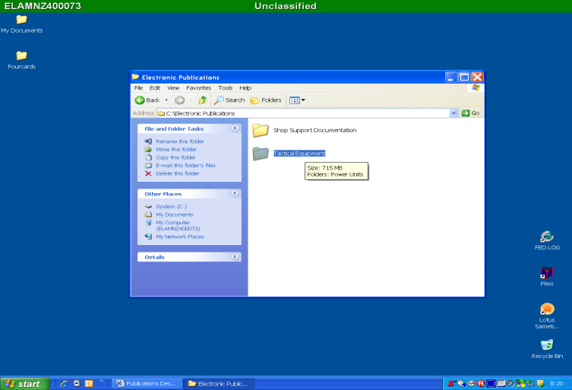
- From here, you can locate and access any publication the Maintenance Section has on file. (Note: For access to MCO, NAVMC and other administrative related publications, simply back track and access shop support documentation rather than Technical Publications.)

Classification of Publications:

- Directives:

  - Non-Technical Publications: Orders and bulletins issued by various echelons of command which provide information and guidance on various maintenance programs. (Note: The requirement to maintain non-technical publications is a judgment call by the commodity manager.)

  - Advanced Logistics Orders (ALO): A document providing information relative to the introduction of new equipment and necessary logistical/supply action required prior to placing the new equipment into service.

- Technical Publications:

  - Technical Manuals (TM): A technical publication that contains the description of a piece of equipment, along with instructions for effective operation, preventative maintenance, corrective maintenance, and overhaul for said piece of equipment.

- Joint Service Publication: Similar to a Technical Manual, this publication originates when two or more services coordinate in its authorship for a piece of equipment.

- Lubrication Instruction/Order (LI/LO): This set of instructions prescribes the types of lubricants to be used, the points to be lubricated and the interval between lubrications for a piece of equipment.

- Modification Instruction (MI): These instructions are used to support a Marine Corps wide modification program. They are used to correct discrepancies in equipment design; to give equipment increased technical and tactical advantages. There are two types:

  - Normal Modification: The modification must be completed on all affected pieces of equipment within one year of the date of issuance.

  - Urgent Modification: The Modification is issued to prevent personal injury or serious damage to equipment. Message instructions will normally be issued to deadline equipment till the modification is installed. This modification must be completed within the timeframe stated on the MI.

Classification of Publications (continued):
- Technical Publications:

    - Supply Instructions (SI): A set of instructions that furnish supply information that explains the technical aspects of supply for specified items of equipment.

    - Technical Instructions (TI): A set of instructions that gives you added information usually included as a change or revision to a TM. They may also contain information previously included in a TM that can be better disseminated via a smaller instruction i.e. Forms and records to be used, safety and serviceability standards. They can be used to transmit urgent instructions critical to the operation or maintenance of equipment as well.

  - Stock Lists:

    - Supply Catalogue (SC): A given Army Publication which corresponds to Marine Corps SL-3 and SL-4 listings.

    - Stock List 1-1 (SL 1-1): An introduction to the Marine Corps stock list publications and the federal supply catalogue.

    - Stock List 1-2 (SL 1-2): An index of authorized publications for equipment support; it is used to determine what publications are needed to support a piece of equipment.

    - Stock List 1-3 (SL 1-3): An index of authorized publications in stock; included in it are the publications from other branches of the armed services and commercial contractors which the Marine Corps has adopted and authorized for use.

    - Stock List 3 (SL-3): A component list, the SL-3 is used as an inventory guide to an item of equipment.

    - Stock List 4 (SL-4): A repairable parts list that links the mechanic/technician to the supply system; it lists and completely identifies those items and materials required to maintain the end item, components and/or major assemblies.

    - Stock List 6 (SL-6): An application list, it is used to cross reference an NSN to an Item designator (ID) number.

    - Stock List 8 (SL-8): A list of items that are functionally the same and are grouped together for convenience of management at all levels, i.e. blank forms or rifle team equipment.

Terms and Abbreviations:

- DCP – Directive Control Point, which is responsible for maintaining the units Publication Library (PL).

- EDO – Electronic Distribution Only, these pubs are only available electronically

- FMF – Fleet Marine Force

- FSMAO – Field Supply and Maintenance Analysis Office

- SL – Section Library

- IAAC – Individual Activity Address Code, identifies a unit within the Marine Corps

- IAC – Individual Activity Code, is used interchangeably with IAAC

- ISC – Information Systems Coordinator

- ISMO – Information Systems Management Office

- Local Publications – Physical copies of documentation that users want to keep track of. They consist of such things as: BN orders, Div Orders, etc.

- Master List of Publications – Listing of all USMC publications

- NEA – Non Equipment Associated, this allows you to retain a PCN in your section Library even if the ID number is deleted or obsolete.

- PCN – Publication Control Number

- PLMS – Publication Library management System

- SSIC – Standard Subject Identification Codes

- MCPDS – Marine Corps Publication Distribution

